1. What is Git Cherry pic?

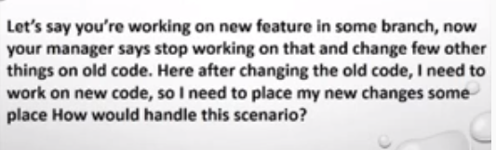

Ans: git stash

3.



Ans: git branch -a

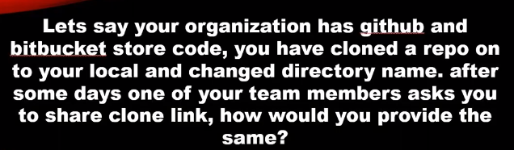

ANS: git remote -v

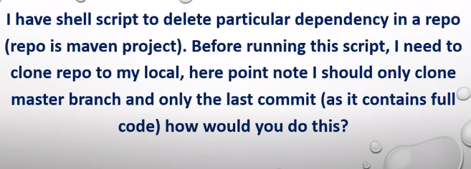

ANS: git clone -b master –single-branch –depth 1 <link>

git log –oneline

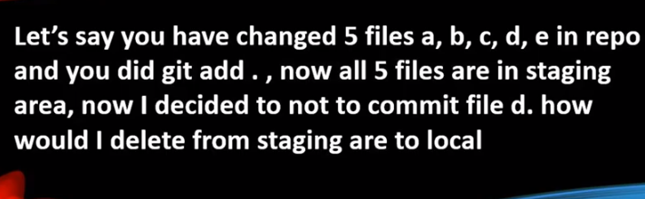

git rm –cached d